Table of Contents

What is OpenStack? 2

Why we need Open stack? 2

Simplicity: - 2

Robust: - 2

Flexibility: - 2

Control: - 2

Private cloud: - 2

What are the components of OpenStack? 2

Nova: - 3

Swift: - 3

Cinder: - 3

Neutron: - 3

Horizon: - 4

Keystone: - 4

Glance: - 4

Ceilometer: - 4

Hardware requirement for OpenStack? 4

How to Install OpenStack? 5

DevStack (Specially for Ubuntu) 5

Mirantis 5

PackStack 5

Steps to Install: - 5

# What is OpenStack?

*“Founded by* ***Rackspace*** *Hosting and* ***NASA*** *in* ***2010****, OpenStack has grown to be a global software community of developers collaborating on a standard and massively scalable open source cloud operating system*.”

OpenStack is a set of software tools for building and managing cloud computing platforms for public and private clouds. Backed by some of the biggest companies in software development and hosting, as well as thousands of individual community members, many think that OpenStack is the future of cloud computing. OpenStack is managed by the OpenStack Foundation, a non-profit that oversees both development and community-building around the project

# Why we need Open stack?

Simplicity: - IT administrators should be able to create their cloud on commodity hardware from a single physical server to hundreds of thousands of servers, without special skills.

Robust: - The software must be stable for long-term operation while allowing developers to add new useful functions.

Flexibility: - Besides the well-known Amazon EC2 model, the software should be able to implement new models that fit traditional enterprise needs. There are many organizations that don't want to lock themselves into a single vendor, regardless of how good or bad this vendor is.

Control: - There are still many cases in which controlling the infrastructure will give you a business advantage in controlling your product margins. That is, using specialized infrastructure that is more optimized for the kind of workload and customers that you are serving, than just general purpose infrastructure.

Private cloud: - You can have your own private cloud in your premises with more security.

Having said that, I think that the most important point is that **OpenStack is not a product** and shouldn't be measured as such**. It's an ecosystem with strong foundations behind it**.

# What are the components of OpenStack?

OpenStack is made up of many different moving parts. Because of its open nature, anyone can add additional components to OpenStack to help it to meet their needs. But the OpenStack community has collaboratively identified nine key components that are a part of the "core" of OpenStack, which are distributed as a part of any OpenStack system and officially maintained by the OpenStack community.

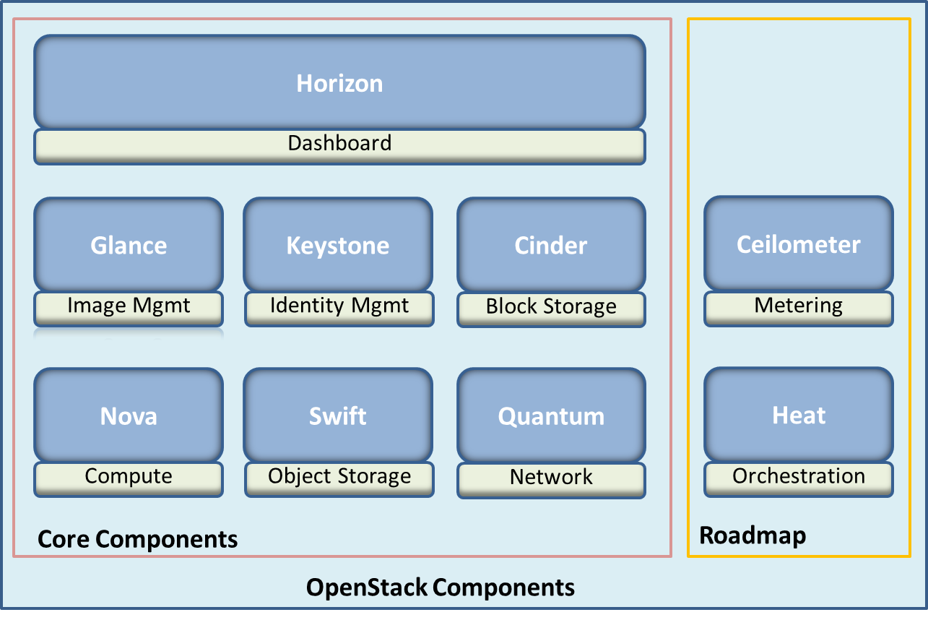

Nova: - is the primary computing engine behind OpenStack. It is used for deploying and managing large numbers of virtual machines and other instances to handle computing tasks.

Swift: - is a storage system for objects and files. Rather than the traditional idea of a referring to files by their location on a disk drive, developers can instead refer to a unique identifier referring to the file or piece of information and let OpenStack decide where to store this information. This makes scaling easy, as developers don’t have the worry about the capacity on a single system behind the software. It also allows the system, rather than the developer, to worry about how best to make sure that data is backed up in case of the failure of a machine or network connection.

Cinder: -is a block storage component, which is more analogous to the traditional notion of a computer being able to access specific locations on a disk drive. This more traditional way of accessing files might be important in scenarios in which data access speed is the most important consideration.

Neutron: - provides the networking capability for OpenStack. It helps to ensure that each of the components of an OpenStack deployment can communicate with one another quickly and efficiently.

Horizon: - is the dashboard behind OpenStack. It is the only graphical interface to OpenStack, so for users wanting to give OpenStack a try, this may be the first component they actually “see.” Developers can access all of the components of OpenStack individually through an application programming interface (API), but the dashboard provides system administrators a look at what is going on in the cloud, and to manage it as needed.

Keystone: -provides identity services for OpenStack. It is essentially a central list of all of the users of the OpenStack cloud, mapped against all of the services provided by the cloud, which they have permission to use. It provides multiple means of access, meaning developers can easily map their existing user access methods against Keystone.

Glance: -provides image services to OpenStack. In this case, "images" refers to images (or virtual copies) of hard disks. Glance allows these images to be used as templates when deploying new virtual machine instances.

Ceilometer: -provides telemetry services, which allow the cloud to provide billing services to individual users of the cloud. It also keeps a verifiable count of each user’s system usage of each of the various components of an OpenStack cloud. Think metering and usage reporting.

# Hardware requirement for OpenStack?

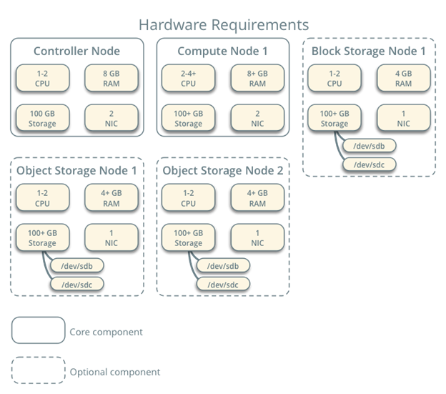

# How to Install OpenStack?

There are different ways to install Open stack.

## DevStack (Specially for Ubuntu)

A series of extensible scripts used to quickly bring up a complete OpenStack environment based on the latest versions of everything from git master. It is used interactively as a development environment and as the basis for much of the OpenStack project’s functional testing.

The source is available at <https://git.openstack.org/cgit/openstack-dev/devstack>.

For installation refer to <https://docs.openstack.org/developer/devstack/>

If you do not have a preference, **Ubuntu 16.04** is the most tested, and will probably go the smoothest.

## Mirantis

To gain experience with the installation and deployment process, most users start by installing OpenStack on their laptop or desktop computer. Mirantis recommends automated installation using OpenStack Fuel and Virtual Box.

**Prerequisites** A 64-bit host OS with at least 8 GB RAM and 300 GB of free space. Virtualization must be enabled in the BIOS. If you use Microsoft Windows, use Cygwin.

For installation refer to<https://www.mirantis.com/how-to-install-openstack/>

## PackStack

*A utility that uses Puppet modules to deploy various parts of OpenStack on multiple pre-installed servers over SSH automatically. Currently only CentOS, Red Hat Enterprise Linux (RHEL) and compatible derivatives of both are supported.*

**Prerequisites** Machine with at least 4GB RAM, preferably 6GB RAM, processors with hardware virtualization extensions, and at least one network adapter.

Here we will mainly focus on how to install OpenStack via PackStack.

### Steps to Install: -

* Install Centos 7 with Virtual Box.
* Give it 6-8GB memory and 4-6 CPUs.
* 1 NIC .
* 20 GB disk space at least.
* If you plan on having external network access to the server and instances, this is a good moment to properly configure your network settings. A static IP address to your network card, and disabling Network Manager are good ideas.

$ sudo systemctl disable firewalld

$ sudo systemctl stop firewalld

$ sudo systemctl disable NetworkManager

$ sudo systemctl stop NetworkManager

$ sudo systemctl enable network

$ sudo systemctl start network

* If you are using non-English locale make sure your /etc/environment is populated:

LANG=en_US.utf-8

LC_ALL=en_US.utf-8

* Install the latest version of Opnstack release.

$ sudo yum install -y centos-release-openstack-ocata

$ sudo yum update -y

$ sudo yum install -y openstack-packstack

* Once all these packages installed you can go for all-in-one approach or you can install specific components for your environment. Below is all-in-one approach.

$ sudo packstack –allinone

OR

$sudo packstat –gen-answer-file=answer.txt

This will create “answer.txt” file in your current directory.

$vim answer.txt

Here in “answer.txt” file you can choose which component you want you can add multiple compute nodes, network nodes, and storage nodes as per your requirement.

Once you are ready run the below command.

$sudo packstack –answer-file=answer.txt

Note- It will take 30-40 minutes to install. For more info on installation refer to<https://www.rdoproject.org/install/quickstart/>

* After installation finish you can see file “**keystone_admin**” in your current working directory. This file will have dashboard url and admin user password.

$sudo source keyston_admin   
$sudo nova list